**Connecting to GitHub from Visual Studio 2017 from DMU lab computers**

## Overview

To connect from Visual Studio to GitHub you will need to change the way that VS authenticates to the GitHub web site.

In this zip file you should find the following

* A copy of these instructions
* A template for creating your own batch file (SetCredentials.bat)

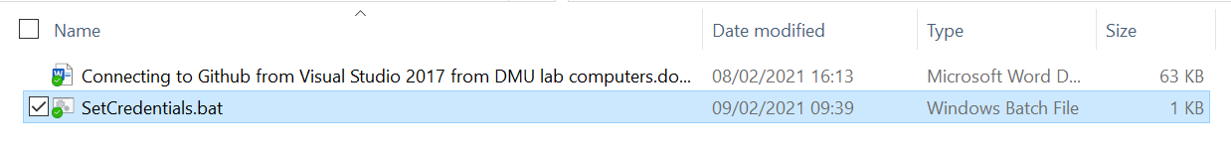

Make sure that you have correctly unzipped all the files before continuing with these instructions.

To gain access you will need to do the following…

* Create an access token under your account on the GitHub web site
* Make a copy of the access token and keep it in a safe secure place
* Modify the batch file provided in this download
* Run the batch file by double clicking it before you need to access GitHub using VS

## What you need to do

**1:** Go to the following URL and if required log in with your Github account:

<https://github.com/settings/tokens/new?scopes=repo,gist,workflow>

This should open the page to create an access token and should have automatically selected **“repo”** (including all its child properties), **“gist”** and **“workflow”**. If not then please make sure they are ticked.

**2:** In the **“Note”** box give your token a name (i.e. What’s this token for?)

Scroll down and click **“Generate token”**

***NOTE: On the next screen you must make a note of the token as you will not be able to view it again. I would advise copying it to a text document and storing it securely. This is also the same page where you can delete any existing tokens you have created previously.***

**3:** From Windows Explorer right click on the batch file template provided in the zip file and select edit…

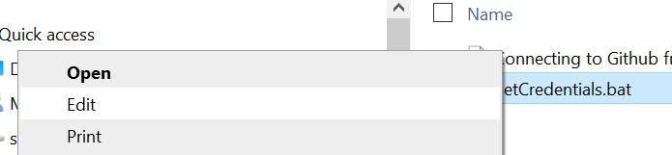

This will display the contents of the batch file…

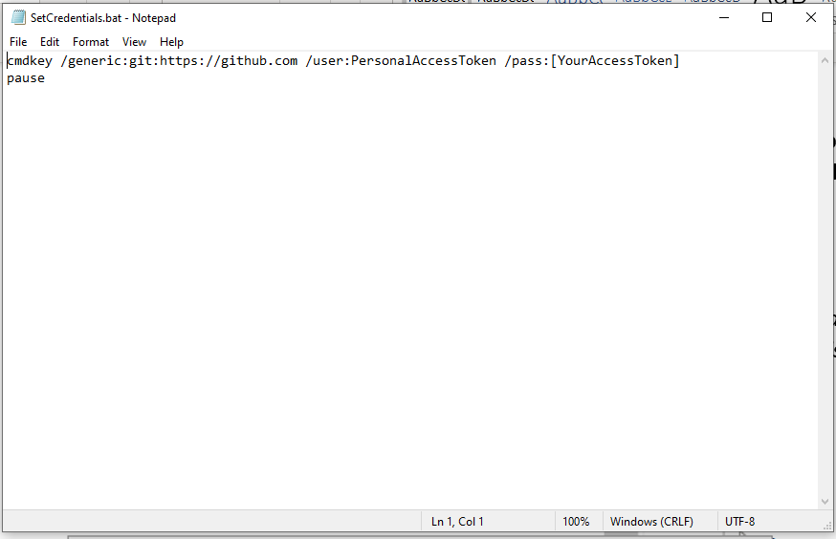

You will need to replace the following text with the access token generated in GitHub …

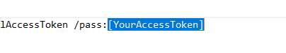

**Make sure that you remove the brackets from the original otherwise this will not work!**

Close and save the file in a safe secure place.

**4:** Double click the file to run it, you should see the following response:

***CMDKEY: Credential added successfully.***

You should now be able to clone/push/pull to your repo within Visual Studio 2017.

Important, each time you login to Your DMU you will be allocated a different lab machine, this means that you will need to repeat step 4 each time you access the DMU network remotely.

**Make sure that you keep a copy of the batch file in a secure place and do not give it or the access key to another person as this will allow them full access to your GitHub account.**